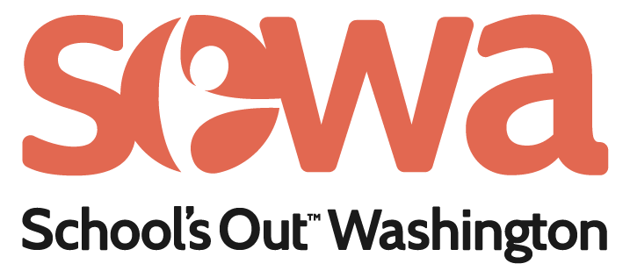

**Outcome Measures Warehouse and Guide**

SOWA Refugee Student Impact Program, ARSI URSI Programs

This document outlines SOWA’s approach for measuring youth outcomes in the ARSI URSI programs. It was prepared by the Strategy, Evaluation, and Learning department of Puget Sound Educational Service District.

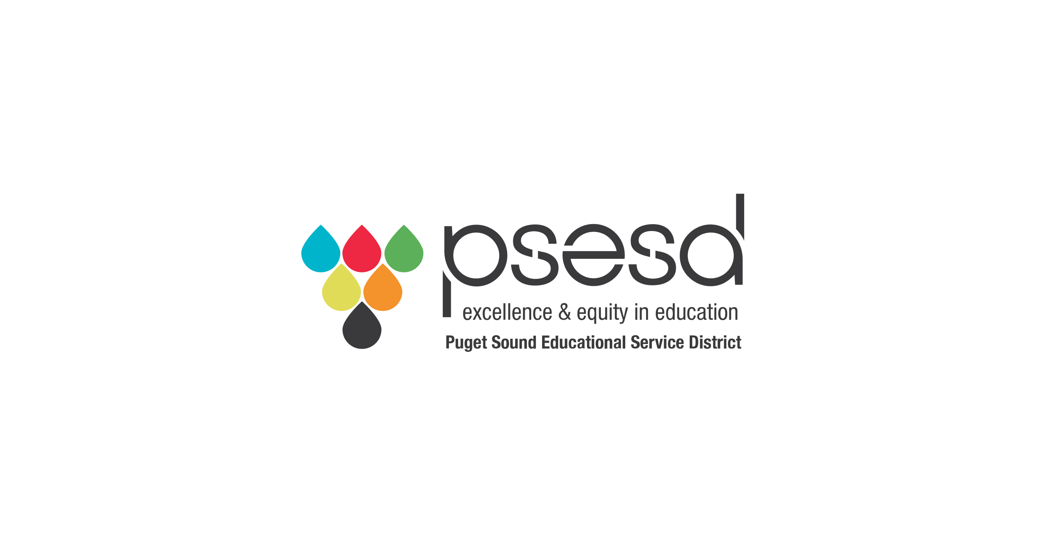

Contents

Contents 2

Glossary 3

Evaluation Planning 4

Outcomes and Measures 6

Language Translation Considerations 6

Creative Ways to Gather Feedback Beyond Surveys 6

Academic Support Measures 8

School and Social Integration Measures 10

Social Emotional Learning (SEL) Measures 12

Additional Tools for Social-Emotional Skill Measurement 13

Appendix A: Notes on Measuring at Multiple Points 15

Pre/Post 15

# Glossary

**Evaluation:** An overall approach used to gather information or data to answer specific evaluation questions. Evaluation can help programs understand who benefits from their work and how they benefit. When used for learning and reflection, evaluation data supports program improvement and responsiveness to student needs.

**Theory of Change:** A detailed set of beliefs about the changes that are expected to happen because of a program or set of activities. Theory of Change is often represented as a model with activities conducted by a program and resulting near-term outcomes, middle-term outcomes, and long-term outcomes for participants.

**Outcome:** The change that is expected for participants of a program or because of an intervention. Also called the impact of the program.

**Measure or Measurement:** The qualitative or quantitative statement used to track changes in outcomes for individual students.

**Quantitative:** Data is represented numerically, including anything that can be counted, measured, or given a numerical value (such as counted the number of times a word or phrase is said during an interview or focus group)

**Numeric Services Data:** Data that generates numbers from things like attendance or sign in sheets; recording numbers of interactions; recording numbers of referrals; etc.

**Quantitative Survey Data:** Closed survey questions that require a respondent to select a response from a set of answers or options.

**Qualitative:** Data that is information or concepts not represented by numbers. Often uses focus groups or interviews as data collection. Can also include data such as maps, notebooks/notes, photographs, or other printed materials or observations

**Focus Group:** Group conversation using either a pre-determined set of questions or prompts that lead the group in conversation.

**Interview:** Individual conversation using either a pre-determined set of questions or prompts that lead the conversation.

**Qualitative Survey Data:** Open ended questions on a survey that allow for written responses.

# Evaluation Planning

Evaluation planning requires time and resources. The steps below may take several days and may best be completed by a group of individuals familiar with the program. Whenever possible, incorporate feedback from students about what is important to them and how they feel most comfortable answering questions about the benefits of your program. Considering the needs and perspective of participants helps ensure that evaluation results are relevant, accurate, and useful for the program.

The steps below are designed to be a general guide to the process. Use them to start thinking about evaluation and consider if your program has additional considerations or steps that need to be followed.

1. **Select 1 outcome** to report to SOWA. You are welcome to select more, but you only need to report on one as part of this grant. When selecting an outcome, you will be asked why the outcome you select is meaningful for the students that participate in the program.
2. **Select at least 1 measurement that is most meaningful** for your program. You are welcome to select more than one measurement, but you only need to report on one as part of this grant. For each outcome, there are multiple options for measures. For older students and parents, the options are survey questions. For younger students, you may see a movement survey or staff observation.

Generally, SOWA recommends using a survey to measure the outcomes in this document. In some cases, particularly for elementary students, a movement or simplified and tactile survey adaptation is suggested. Many of these suggestions come from or are adapted from the report ["Creative Ways to Solicit Feedback"](https://www.publicprofit.net/wp-content/uploads/2023/08/Creative-Ways-to-Solicit-Feedback.pdf) which adapts ideas from the first report for youth in school environments. For these types of measures, you may offer “yes/no” answers or options based on your program (for example, asking students if they know the routine for the day). You’ll count positive responses based on the way you ask the question. You will find more detail on these types of measures in the warehouse below.

All the example survey items in this guide are listed in positive language. This means that when people agree with the statements, they agree to a positive improvement.

We recommend that programs use a 4-point scale for survey responses: Strongly Agree, Agree, Disagree, Strongly Disagree.

1. **Decide if the measure needs to be translated from English** to another language (see language considerations below). **Choose a time and place for measuring outcomes**.
   1. See language translation considerations below.
   2. The measures in this document are designed to be used at the end of the program and they include language that indicates improvements since participating in the program. You can also choose to do before and after (also called pre/post) measurement with students. Some notes on this method are included in Appendix A.
   3. Consider whether a digital survey, paper survey, or other method is most appropriate for your measure and where/when you’ll offer the survey.
2. After you choose what to measure and how you will measure it, **create a plan for storing and analyzing the results** of the surveys or other measures. Make sure that any data reporting does not link individual student identity information with evaluation results.
   1. When analyzing data, if you use a 4-point scale for responses, count Strongly Agree & Agree as positive responses for each participant. You can then calculate the proportion of all participants who responded positively. In some cases, you may want to include an option for “I don’t know.” This response can be excluded from the proportion calculation.
3. **Report the data back to SOWA** using the provided form or your own method. If you choose one of the suggested measures, you will be asked to report on the number of positive responses and the number of total responses. If you choose another method, a different way of reporting data may be arranged. You may also choose to adjust and improve your program based on the results you’ve gathered with this process.

# Outcomes and Measures

Outcomes in this guide match the near-term outcomes listed on the accompanying Theory of Change example document (if included). The examples below are listed to help you choose relevant, meaningful outcomes to measure for students in your program and that you may expect to accomplish during the reporting period.

## Language Translation Considerations

These examples are provided in English. If your students do not have a high level of English, your program is not run in English, or you know students would prefer to have the survey in another language, please consider translating the survey. Your program may have staff who are multilingual and can serve as translators.

Having more than one person translate, or one person review someone else’s translation, will ensure accuracy and relevance for your students. The best practice for survey translation involves a minimum of two translators, one who translates the survey to the target language, and another who (without reference to the English version), translates it back again. The original and the back-translated version are then compared to see any differences between the two, and the translation is adjusted accordingly. However, we acknowledge that not everyone will have the staff or capacity to use this method for translation.

You are encouraged to change survey wording in English to match a more natural translation for your students in their preferred language. Please be sure that the English version you share with SOWA matches the translation you use with students.

Finally, we understand that words or concepts like “belonging” may be difficult to translate. Please take care with translation for these words, pick the word in the language that you feel best describes the underlying concept, and feel free to provide notes in English that provide more context on connotations on what an English translation of this word in another language might be.

## Creative Ways to Gather Feedback Beyond Surveys

You may decide that a survey is not the best way to collect feedback from your youth and caregivers. There are many other ways to collect responses to measure these outcomes. If you work with children and youth, the chances are you already do activities that can double as data collection methods. Our suggestions for measuring outcomes include some of the ideas below. Feel free to use them or adapt them for your program context.

|  |  |
| --- | --- |
| **FOUR CORNERS Movement Survey** | Four Corners measures the number of participants with certain attitudes or values. Ask youth to move around the room to the corner that matches their response to a close-ended prompt. For example, if you work at an after-school program you can say statements like “I learned something new in this program,” or “I had fun today.” Youth walk to the corner that matches their responses (e.g., Strongly Agree, Agree, Disagree, or Strongly Disagree). Ask youth to share why they chose their corner to learn more details. For younger audiences, simplify with two corners and use symbols (e.g., thumbs up, smiley face, etc.) instead of words. For every question you ask, ensure you write down the number of youth in each corner and details about their “why”. This is what you will use in reporting. |
| **TOKEN SURVEY** | Token Survey is an unobtrusive way to get responses to closed-ended questions. This activity could work for either youth participants or caregivers. First, develop your question and response options. This activity works best with only one question at a time. Create a sign with the question and a jar label for each response option. Place each label on a separate jar. Response options can include standardized responses (e.g., “Strongly Agree”) or specific responses (e.g., “I bike to work.”). Labels can include multiple languages. Depending on the question, you might also include pictures so that reading is not necessary to participate. Give each person a token and have them respond to the question by dropping their token into the jar that matches their response. Then, document how many tokens are in each jar. |
| **HOST A “QUESTION OF THE DAY”** | Youth (and caregivers) respond well to routines, so why not make data collection part of your routine too!? You can host a “question of the day,” choosing a different outcome question each time you host. This process could look very similar to the token survey (explained above): each day, at the end of the program, you ask youth participants to participate in one token survey question before they leave the program for the day. Set up a booth with a question written in the languages that are most accessible to your participants or print out pictures of the answer options. Each picture is on a separate bucket. Then youth can come up, take a token, and place it in the bucket with their answer. Doing this multiple days in a row will help youth get into a routine and know exactly what to do when they see your booth. Then, every day, document how many tokens are in each jar. |

If you’re interested in exploring other creative ways to collect feedback, [Public Profit’s Creative Ways to Solicit Stakeholder Feedback](https://www.publicprofit.net/Creative-Ways-To-Solicit-Stakeholder-Feedback/) is a valuable resource filled with hands-on activities that you can use to gain insight about your program.

Academic Support Measures

The measures below are relevant for programs that support students’ academic growth and development.

| **Outcome** | **Suggested Survey Items for Middle High School Students** | **Suggested Measurement with Elementary Students** | **Suggested Survey Items for Parents or Caregivers** |
| --- | --- | --- | --- |
| Students increase knowledge or skills (e.g., STEM, English, arts, other skills) | "I learned new things at this program.", "I learned how to do new things at this program.", "Since coming to this program, I got better at (activity or area of focus: e.g., arts, reading, coding, sports).", "I feel proud of what I've learned in this program." | Use a movement survey (see Four Corners) or a token survey (See Candy or Token Survey) to have students respond to the question: "I learned something new in this program." Give students a yes or no option. Count all "yes's" as positive. | "My student learned new things at this program.", "My student learned how to do new things at this program.", "Since coming to this program, my student got better at (activity or area of focus: e.g., arts, reading, coding, sports)." |
| Students increase enjoyment in learning | "This program helps me enjoy learning.", "This program helps me feel like I can reach my goals.", "Since coming to this program, I know that if I don’t know how to do something, I can figure it out." | Use a movement survey (see Four Corners) or a token survey (See Candy or Token Survey) to have students respond to the question: "I enjoy learning about (content area)." Give students a yes or no option. Count all "yes's" as positive. | "Since coming to this program, my child seems to enjoy learning more." |
| Students develop positive attitude/interest in subject areas (i.e., STEM) | “I like to learn in (STEM) class.”, "I felt excited to come to (STEM) class.", "I enjoyed the content of the (STEM) class.", "I tried my best on (STEM) assignments." | Use a movement survey (see Four Corners) or a token survey (See Candy or Token Survey) to have students respond to the question: "I enjoy learning about (content area)." Give students a yes or no option. If the program covers multiple topics, the activity could run after each topic wraps up and serve as a part of the program routine. Count all "yes's" as positive. | "Since coming to this program, my child seems to enjoy (STEM/ other subject area) more." (Adapted from existing grantee items) |
| Students increase their knowledge about graduation/ college/ career | "Since coming to this program, I know more about how to graduate from high school.", "Since coming to this program, I know more about options for college or learning after high school.", "Since coming to this program, I know more about my career opportunities." | Not likely relevant for this age. | Recommend asking students directly. |

These measures do not include school test scores or other school-collected data. School test scores or other school-collected data may be helpful to measure mid-term outcomes for students. Collecting and reporting individual student test scores often requires Data Sharing Agreements (DSAs) with school districts and can be resource intensive. Using data that schools or districts report publicly takes less time from programs and can be used to show general student progress (for example, ELL student achievement for a particular year). This data is generally reported about one year after it is collected.

School and Social Integration Measures

| **Outcome** | **Suggested Survey Items for Middle High School Students** | **Suggested Measurement with Elementary Students** | **Suggested Survey Items for Parents or Caregivers** |
| --- | --- | --- | --- |
| Students improve understanding and adjustment to school routines, school behavior expectations | "Since coming to this program, I understand my school schedule and can find all my classes.", "I know what to do when the school bell rings", "I know what happens at assembly time." | Use a movement survey to both teach and assess students' understanding of specific school routines or expectations. For example, "Where do you go to find the school bus at the end of the day?". Count the number of students who get the "right" answer and then use the opportunity to remind students who didn't know. | "Since coming to this program, my child understands school routines better.", "Since coming to this program, my child understands school behavior expectations better." Note: Add a "Do not know" option and remove those from any analysis. |
| Students increase their comfort with school and schoolwork | "In this program, I learn skills that help me in school." | Older elementary students may be able to use the question suggested for middle and high school students. For younger students, it may be easier for parents/caregivers to assess than for students to accurately share (they may want to please the staff or teacher or may think there is a “right” answer). | "Since coming to this program, my child is more comfortable with school.", " Since coming to this program, my child is more comfortable with their schoolwork." |
| Students increase knowledge about available resources and support | "Since coming to this program, I know how to make an appointment with my school counselor or advisor.", " Since coming to this program, I know how to sign up for after school programs that I am interested in." (Adapted from existing grantee items) | Use a movement survey to both teach and assess students' understanding of available resources and support. For example, "Who can you ask for snack at this program?". Count the number of students who get the "right" answer and then use the opportunity to remind students who didn't know. | Recommend asking parents about their experience with the school system rather than having them guess about their children, especially for elementary aged students |
| Students increase confidence speaking English. | "Since coming to this program, I have increased my confidence in speaking English in the classroom.", "Since coming to this program, I can communicate what I want to in English with my teacher.", "Since coming to this program, I can communicate what I want to in English with other students." | Older elementary students may be able to use the question suggested for middle and high school students. | Parent/Caregiver surveys may be particularly helpful for younger grades/ elementary students: "Since coming to this program, my child has increased confidence speaking English." |

Social Emotional Learning (SEL) Measures

Several of the 2023-2024 grantees (7) identified social emotional learning as a core part of their program activities, although there was a wide range of activities and expected types of changes. The items below may be helpful for programs that want to measure near-term social emotional improvements for students. These measures are included in the example Theory of Change for Social and School Integration.

| **Outcome** | **Suggested Survey Items for Middle High School Students** | **Suggested Measurement with Elementary Students** | **Suggested Survey Items for Parents or Caregivers** |
| --- | --- | --- | --- |
| Students increase their enjoyment of and ability to connect with peers. | "In this program, I learn how to work out my problems with others.", "This program helps me make friends.", "This program helps me listen to others.", "In this program, I work with others to reach our goals." | “I make friends in this program.”, “I learn to listen to others when I am in this program.”, “In this program, I learn to solve problems with others.”  Share a paper survey with a 3-point pictorial scale (frown, straight face, smile). | "Since coming to this program, my child has learned how to make friends." |
| Students develop an increased feeling of belonging or community. | "In this program, I felt like I belonged.", "Since coming to this program, I feel like I belong.", "I have a friend at this program.", “I feel like I belong in this class/program.”, “I feel safe in class/program.”, "I trust my teachers in this class/program." | *Not recommended for this age.* | Measuring through parent survey may be helpful for elementary age students: "Since coming to this program, my child feels like they belong at school.", "My child enjoys being with others at this program.", "My child has a friend in the program.", "My child has developed strong relationships with other children in this program." |
| Students increase their sense of confidence/ self-esteem. | "Since coming to this program, I feel more confident.", "This program helps me stand up for myself." | “In this program, I am not afraid to try new things and see mistakes as a chance to learn.” Share a paper survey with a 3-point pictorial scale (frown, straight face, smile). | "Since coming to this program, my child seems more confident." |
| Students increase belief in their ability to succeed. | "This program helps me work hard toward my goals, even if things get hard.", "In this program, I can work hard and improve my skills." | “In this program, I am not afraid to try new things and see mistakes as a chance to learn.” Share a paper survey with a 3-point pictorial scale (frown, straight face, smile). | "Since coming to this program, my child is more confident about working hard towards their goals." |
| Students improve emotion management. | "Since coming to this program, I am better at knowing how I feel.", "This program helps me learn ways to handle all of my emotions." | “In this program, I learn to say how I feel.”, “In this program, I know what to do when I feel angry or sad.”  Share a paper survey with a 3-point pictorial scale (frown, straight face, smile). | "Since coming to this program, my child seems better at identifying their emotions.", "Since coming to this program, my child seems better able to manage different types of emotions." |

## Additional Tools for Social-Emotional Skill Measurement

The [Collaborative for Academic, Social, and Emotional Learning (CASEL)](https://d.docs.live.net/bf1ce93edfc8eaa3/Desktop/SOWA%20RSIP/)%20https:/casel.org/state-resource-center/assessment-tools/) provides several additional options and lists of relevant resources around social emotional learning and use of the data, particularly for program development. Edutopia’s article about the [state of SEL assessment](https://www.edutopia.org/article/assessing-social-and-emotional-learning/) may also be helpful for grantees.

For students in earlier elementary grades, it may be possible to conduct interviews about belonging and caring adults. One simple set of 6 questions is the [HOPE Scale](https://ospi.k12.wa.us/sites/default/files/2023-11/hopescale_hys.pdf) that can be scored together. Programs can determine a “positive” score.

Another option [is a more visual self-reflection](https://www.teacherspayteachers.com/Product/Student-Self-Reflection-with-Glows-and-Grows-EDITABLE-8657526?st=c468b4466bf798301552f123b877136c). Note that these examples are in English and have not been interpreted for a refugee cultural context.

Storytelling can be a good option for elementary aged students; students can share stories of belonging and experiences with caring adults. Stories can be analyzed for themes and both themes and quotations (de-identified) can be shared for evaluation.

Observational tools are also common and may be used by staff and parents. Some examples:

1. In early learning, the Teaching Strategies GOLD Assessment is used by parents and teachers, with items that include: shows ability to adjust to new situations; stands up for rights; demonstrates self-direction & independence; takes responsibility for own well-being; follows classroom routines; follows classroom rules; plays well with other children; recognizes the feelings of others and responds appropriately; shares and respects the rights of others; etc.
2. The Devereux Student Strengths Assessment (DESSA) for K-8th grade is also a teacher assessment. There are options for K-5th grade that can be [purchased online](https://www.kaplanco.com/product/20398/dessa-sse-record-forms?c=17%7CEA1000#mz-expanded-view-1577071376593); these may be able to be borrowed and adapted using acknowledgement.
3. [Grade-level based SEL expectations](https://static1.squarespace.com/static/5b5882f8b98a78554648ca48/t/5db0ec08f0e2ab6cee41c587/1571875849044/SEL+Grade+Level+Expectations+k-12.pdf) could be scored by staff. This example includes expectations through grade 12.

# Appendix A: Notes on Measuring at Multiple Points

The Outcomes and Measures Warehouse is geared towards conducting a survey of some variety near the end or at the end of a program. The suggested measures in the warehouse generally include language specifically asking about something in the context of the program, for example, "Since coming to this program, I feel more confident." This measure asks directly for only the gain in confidence a student might have received since coming to the program. While this does not establish causality (i.e., we still won’t know based on the answer to this survey question whether the program is directly responsible for any increased confidence in the respondent), but it does help establish the extent to which the respondents feel they have benefited in some way from the program.

The above method is recommended because it is the most straightforward. However, you may want to use a pre/post model for assessing growth in program participants.

## Pre/Post

One way to approach evaluation is to have students fill out a survey or otherwise answer questions at the beginning and end of the program. In this case, it is important to be specific in the outcome and measure because students aren’t going to directly attribute increases to the program. Instead, you would measure the differences from the pre-program survey and post-program survey.

As stated earlier, it is important when using this method to be as specific as possible in outcomes and measures. For example, if the program is specifically aimed at increasing students’ confidence in their school/academic environment, then it is better to specify this than use a more general “Students gain confidence”. This is because, if you asked something like “I feel confident in myself”, growth in this over time could be caused by many factors (increased age, increased time in country, etc.). Something like “I feel confident navigating my school and classes” is likely to be more directly due to the program or school. That being said, a pre/post method does not establish a causal link, and if your program is aimed at more general senses of well-being, there may not be easy ways to be more specific.

One method of doing this could be to include the initial question from the pre-program on the post-program survey, but add some items specific to the program on the post-program survey. More general qualitative survey questions can be a good way to gather information on your program, and there are a lot of different questions you could use to gather information (For example: “What did you enjoy most about the program?”, “What were the parts of the program (if any) that helped you feel more confident?”, etc.). However, these questions should be in addition to the initial question. You cannot just change the initial item from a general (“I feel that I have places where I belong”) to a specific (“In this program, I feel like I belong”), because that would lose the main benefit of doing the survey twice—namely that you can compare across time and measure changes between the survey administrations.