Worksheet: Budgeting for Evaluation
No matter what kind of evaluation you are doing, there are costs involved. These costs fall into several main categories: staffing, materials and supplies, equipment (e.g. recording devices, computer hardware and accessories), and travel. The following Excel spreadsheet provides a generic example of an evaluation budget. It is available for download on the YDEKC website at https://ydekc.org/resource-center/sample-evaluation-budget/:

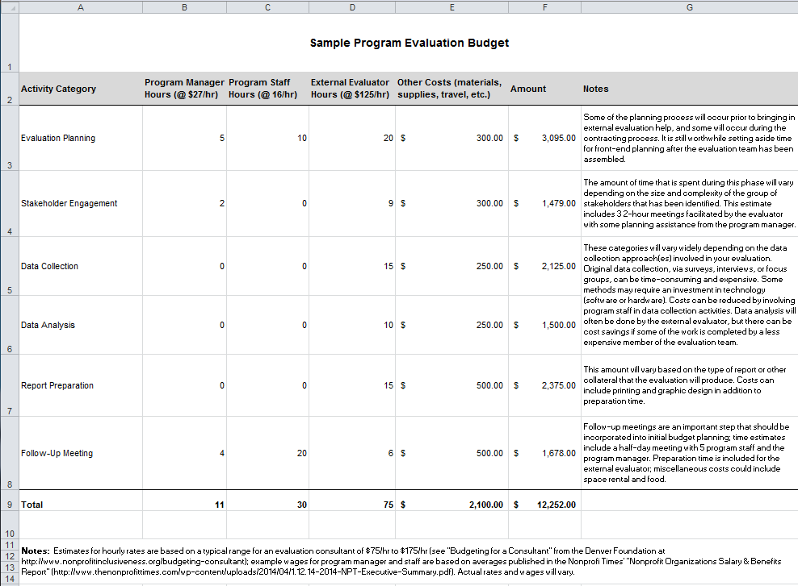

Visit the online version of our Measurement Toolkit at http://ydekc.org/measurement-toolkit/ to find this and other interactive tools.

